

**“We have found the project management coaching very useful in planning and managing our work load... to give us a good balance between theory and practice. The greatest benefit in having a mentor is that it provides valuable guidance on how best to manage our current projects as issues arise, something that a text book approach cannot provide.”**

**Michael Hanafi from Good Beginnings**

**Project Management Coaching for Not For Profit Organisations**

The Community Coaching Program (CCP) is run by experienced project managers who volunteer their time to coach Not for Profit (NFP) organisations in better project management practices.

Our services are tailored to each organisation depending on their unique requirements and may include project health checks; workshops on specific issues; one to one coaching; introductory training; post implementation reviews; and more.

We can assist Not for Profit organisations to:

* Establish a project management framework
* Establish project documentation templates
* Create a project charter and project schedule
* Identify and manage stakeholders
* Track project status
* Prepare project minutes and status reports
* Identify, report and track project issues and risks
* Create effective communication
* Learn project management terminology

**History of the Community Coaching Program**

Following the success of the PMI Minnesota Chapter in running a similar program, the PMI Sydney Chapter decided to establish the Community Coaching Program in late 2009 to encourage Sydney based Not for Profit organisations to use project management practices.

A call for volunteers was issued and a team was formed under the leadership of Melanie Kassar. The project charter was approved in early 2010 and following this the team focused on creating operational procedures and documentation to help support the delivery of the program.

In 2011 the program was piloted through a coaching project with Special Olympics Australia. Moving into 2012 we now have a new leader, Suzy Turner, and are currently working with 3 Not for Profit organisations providing ongoing coaching and education support.

Thank you to all volunteers past and present who have helped develop the program over the years!

**Relationship with BBF**



**The Community Coaching Program operates under the Building Better Futures (BBF) portfolio, which is a community focused campaign established by the Project Management Institute Educational Foundation (PMIEF), the philanthropic arm of the Project Management Institute (PMI). PMIEF’s mission is to champion the development of project management knowledge and skills in the education and community sectors.**

Community Coaching Program - Let’s Take a Closer Look

*[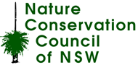](http://nccnsw.org.au/)*

**Co.As.It...**

*...is a non profit organisation for Italians and Australians of Italian descent, providing aged care and educational services to the community. Our team recently gave a presentation to their senior management on project management practices leading to the CCP now providing hands on practical coaching to assist Co.As.It with an office relocation project.*

**Nature Conservation** **Council...**

*...manages environmental campaigns and advocacy work and is also an umbrella organisation for 100 small environmental groups around the state. Our team recently undertook a review of their strategic and operational planning & reporting documentation. We are also providing ongoing 1:1 coaching support to their sustainability project team and we are discussing partnering with Nature Conservation Council to deliver a program of seminars during 2012/13 on project initiation, implementation and evaluation.*

**Good Beginnings...**

*...provides free early childhood and practical parenting programs for children and families across Australia. We are providing coaching and mentoring to two Project Managers responsible for 5 projects. Ranging from infrastructure procurement, data migration to contract negotiations. We work through the project lifecycle and advise practical approaches to different situations specific to the organisation and each project.*

**Current NFP Interactions**

Community Coaching Program - Who are we?

**Team Leader:**

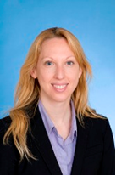

**Suzy Turner, PMP, PRINCE2**

**Team Members:**

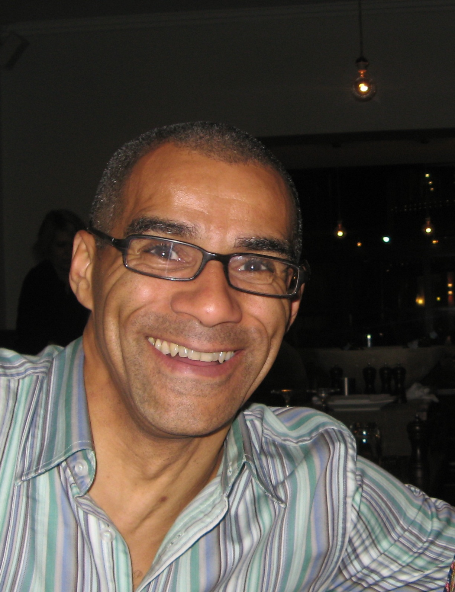

**Michael Chilcott**

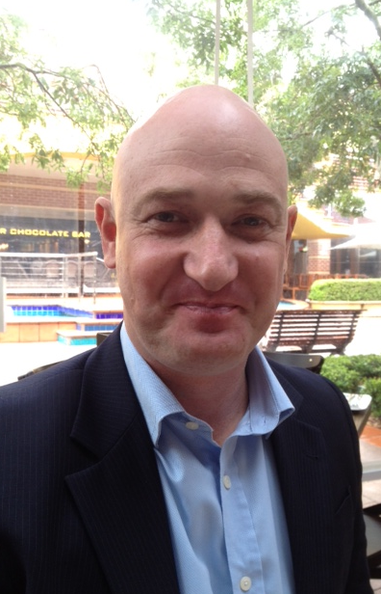

**Tony Briggs, PMP**



**Jodie Assaf, PMP**

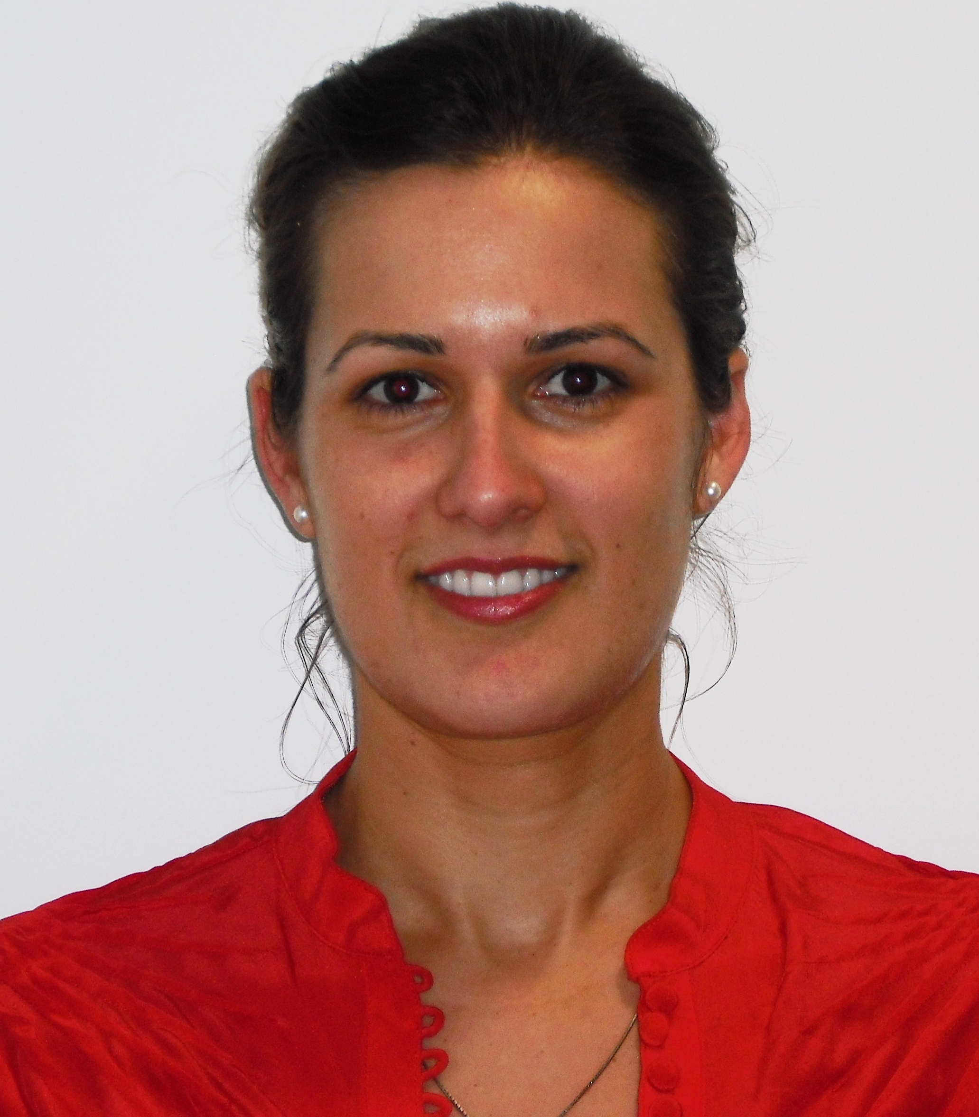

**Venesa Lalic, PMP**



**Selin Akbasogullari, PMP**

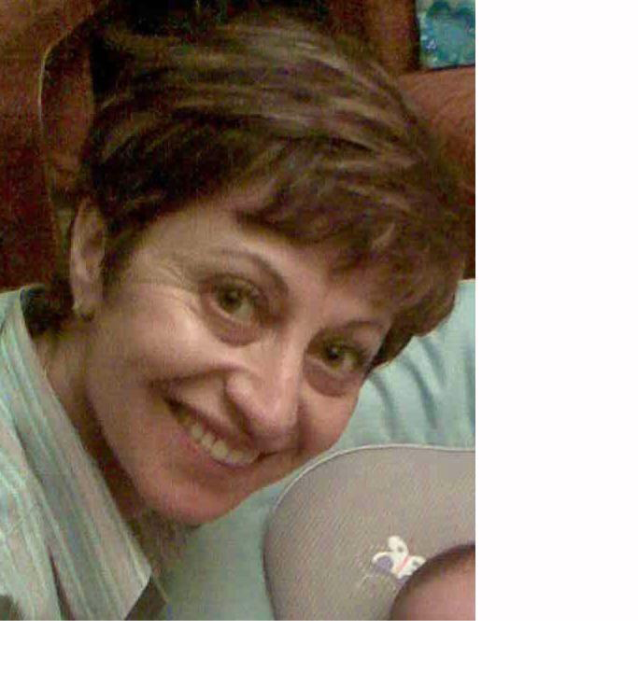

**Amany Nuseibeh, MBT, PMP, CPPD, MSP Practitioner**

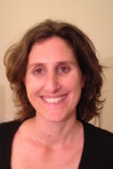

**Spotlight on a Volunteer**

*Tony Briggs joined the Community Coaching Program in January 2012 and is   
currently working with Good Beginnings providing 1:1 coaching support.   
We asked Tony a few questions and why he volunteers for the program.*

**Tony, tell us a little bit about yourself?**I have been working as a manager in the IT space for the past 10+ years, moving into project management about 3-4yrs ago at the Commonwealth Bank of Australia. I’m married and have two boys aged 10 & 11, I’m also coach to my youngest boys’ soccer team.

**How did you hear about the program and what made you want to volunteer?**Since joining PMI and gaining my PMP I have wanted to find out where I could really add value and still learn more. Searching through the Sydney Chapter website there are many things you can get involved in and volunteer for, I felt BBF was the area that interested me the most and I liked the approach of the Community Coaching Program.

**What do you most enjoy about being a part of the Community Coaching Program?**

I’m working with the Not-for-Profit organisation ‘Good Beginnings’, mentoring and coaching a few of their project managers a couple of hours each week.  This engagement has been fantastic for me because it ticked my number one box, “adding value”.  The team at Good Beginnings has recently asked me to prepare a presentation for their Annual General Meeting attended by all their employees, so the coaching is not only benefiting the project managers that I work with weekly but we are also spreading the word about project management throughout the whole organisation.  I’ve also found working with Suzy and the rest of the Community Coaching Program team a fantastic experience... it’s rewarding to see the results of our persistence and hard work.

**For More Information**

Please email us at ccp@pmisydney.org